SOP for Federated EGA Helpdesk - Release a FEGA dataset

Document Owner | Aina Jené - EGA-CRG Operations Manager
Version | 1.0
Effective date | 31-05-2023

Purpose
The purpose of this SOP is to establish a standardised process for releasing a Federated EGA (FEGA) dataset within the FEGA Helpdesk. The SOP outlines the necessary steps and guidelines to ensure the secure and compliant release of datasets, while maintaining data integrity and protecting the privacy and confidentiality of individuals involved.

By implementing this SOP, several valuable outcomes can be achieved. Firstly, it ensures consistent and controlled release of FEGA datasets, promoting data discoverability and FAIRness.

Scope
This SOP indicates the steps to follow in order to release a FEGA dataset once the user has set up a release date to make the dataset discoverable on the CEGA (Central EGA) website.

Procedure
- A FEGA Helpdesk admin will login to their FEGA Helpdesk Portal (helpdesk.{fega}.ega.archive.org) and
  - Click on “Pending Datasets”
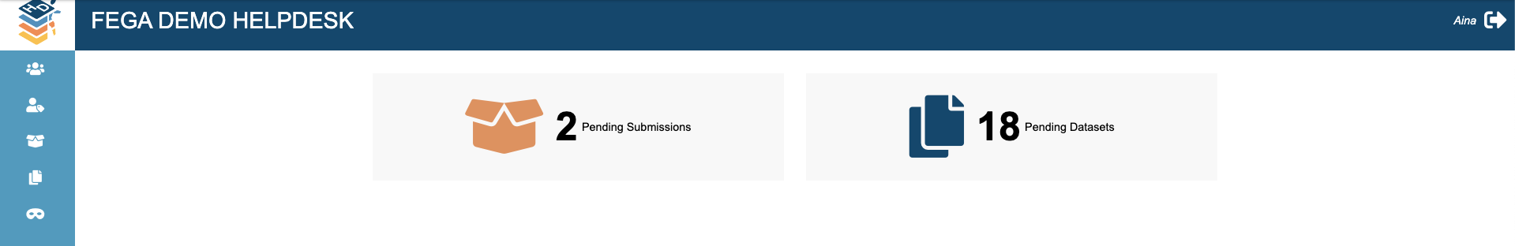
  - go to DATASET RELEASE
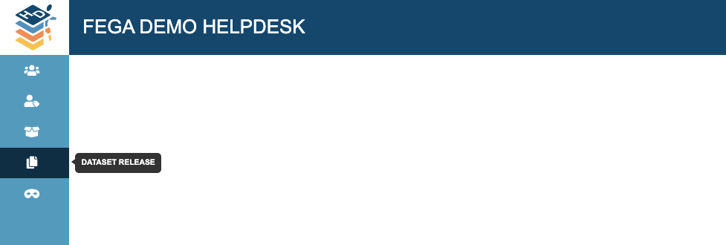
- Check the summarised information in this tab
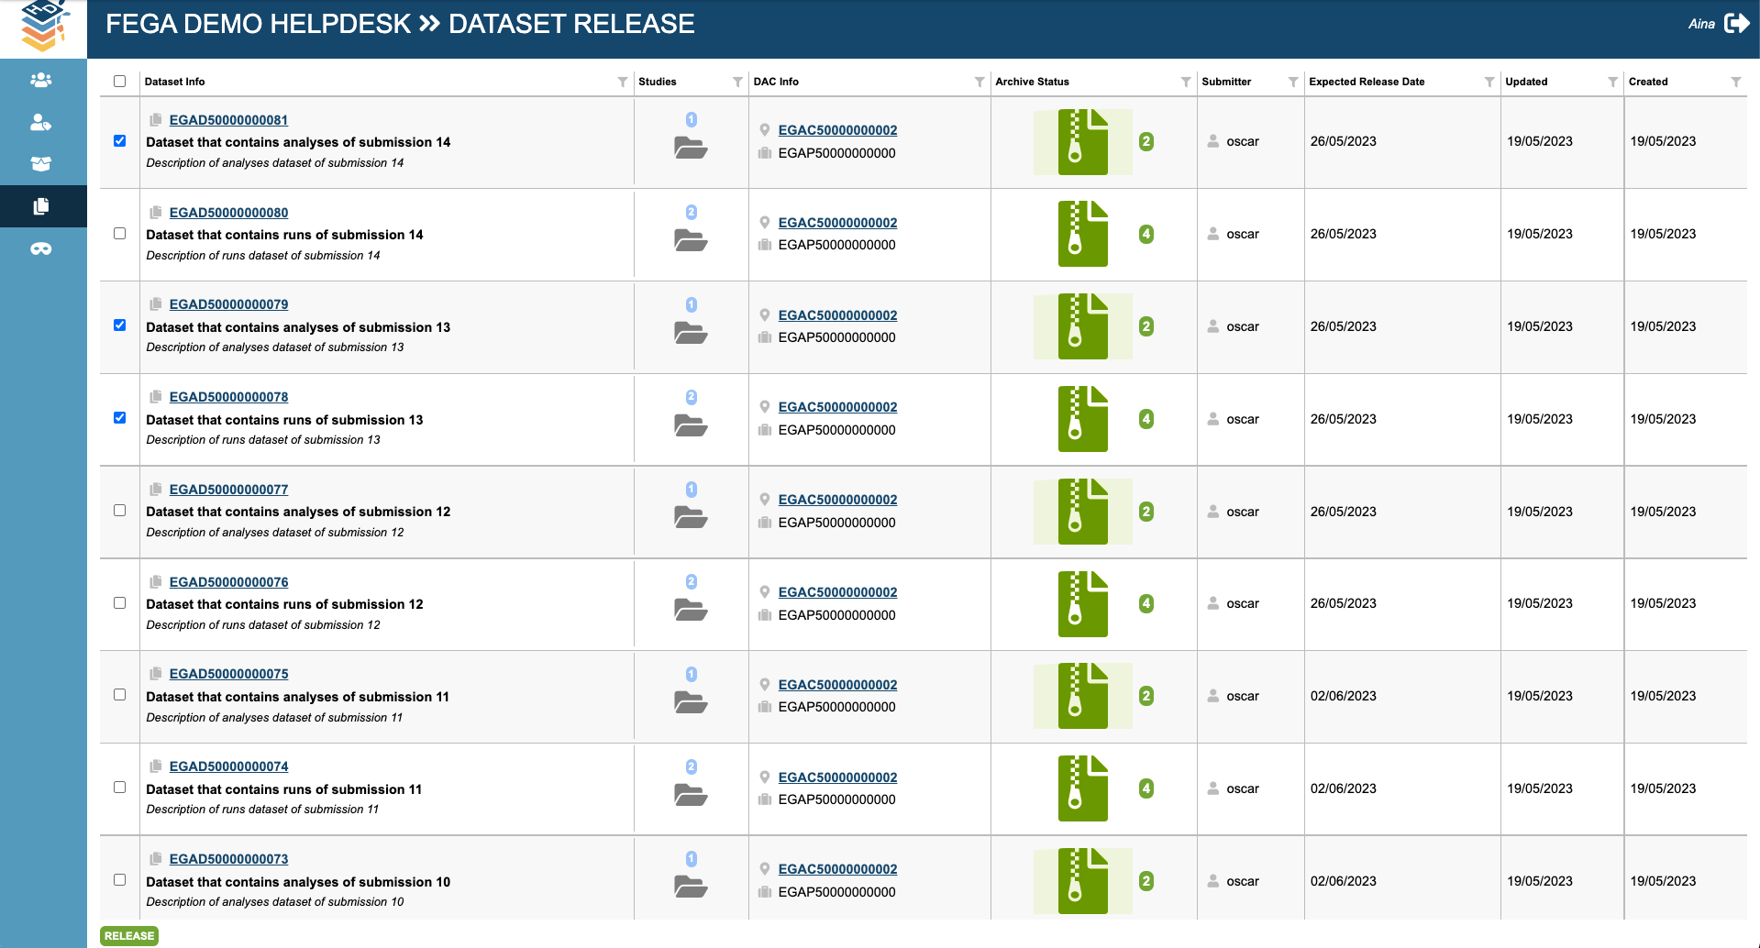
  - Dataset info
  - Study linked
  - DAC and policy linked
  - Number of archived files: it will always show the total number of archived files. Only once the FEGA node has archived the files the submitter will be able to finalise the submission. Hence, the files in this tab should always be archived.
  - Submitter
  - Expected Release Date
  - Date of last dataset update
  - Date of the dataset creation
- Select the datasets you want to release:
  - One by one, by selecting the checkbox available next to the dataset info

  - All at once, by selecting the checkbox on the top. Once you select the top checkbox, it will automatically select all datasets.
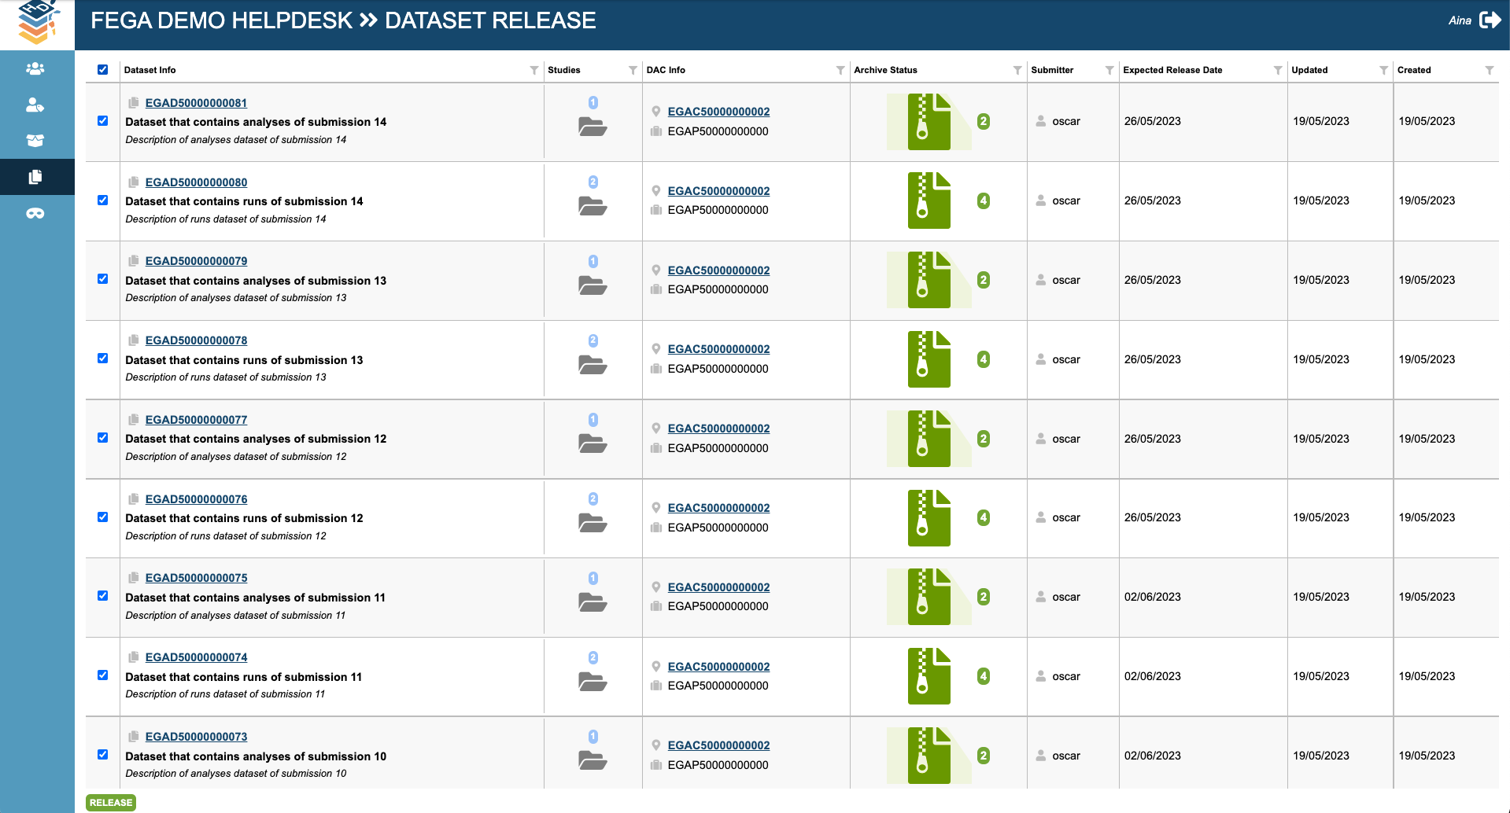
- When you have selected the datasets you want to release click the RELEASE button. It will show a message informing that the datasets have been released successfully
